# Graph

A Graph is a non-linear data structure consisting of vertices and edges. The vertices are sometimes also referred to as nodes and the edges are lines that connect any two nodes in the graph. A Graph consists of a finite set of vertices(or nodes) and set of Edges which connect a pair of nodes.

A Graph G(V, E) with 5 vertices (A, B, C, D, E) and six edges ((A,B), (B,C), (C,E), (E,D), (D,B), (D,A)) is shown in the following figure.

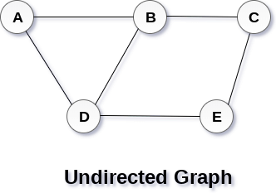

**classification of graph**

1. Directed Graph

2. Undirected Graph

**Directed Graph**

A directed graph is a set of vertices (nodes) connected by edges, with each node having a direction associated with it.

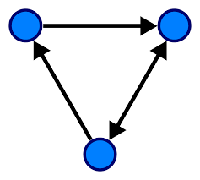 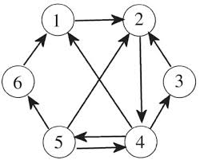

**Undirected Graph**

A Undirected graph is a set of vertices (nodes) connected by edges, without having a direction associated with it. All the nodes are bidirectional.

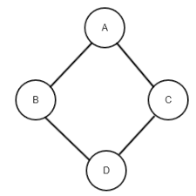 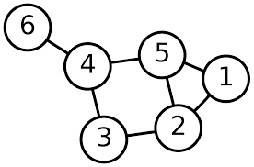

**Graph Terminology**

– Vertex

– edge

– path

– Adjacency

# Graph Representation

There are two ways to store Graph into the computer's memory.

### 1. Sequential Representation

#### 2. Linked Representation

## **Sequential Representation**

In sequential representation, we use adjacency matrix to store the mapping represented by vertices and edges. In adjacency matrix, the rows and columns are represented by the graph vertices. A graph having n vertices, will have a dimension n x n.

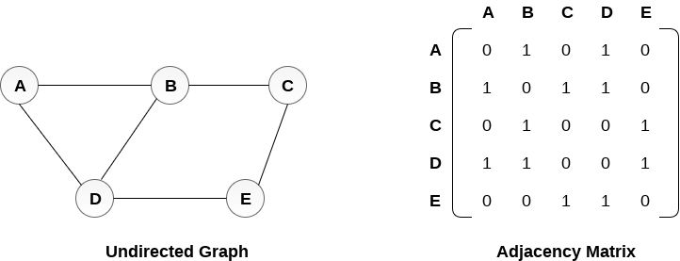

A directed graph and its adjacency matrix representation is shown in the following figure.  
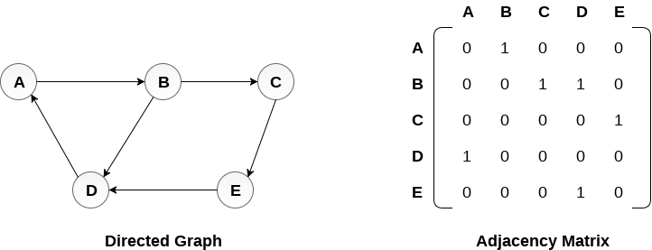

The weighted directed graph along with the adjacency matrix representation is shown in the following figure.

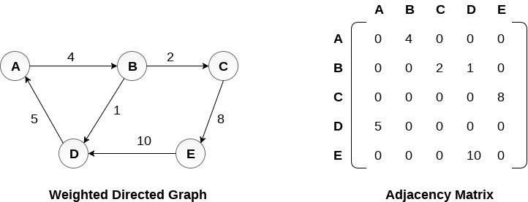

## **Linked Representation**

In the linked representation, an adjacency list is used to store the Graph into the computer's memory.

Consider the undirected graph shown in the following figure and check the adjacency list representation.

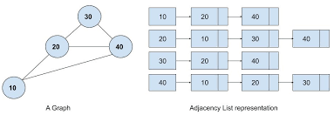

An adjacency list is maintained for each node present in the graph which stores the node value and a pointer to the next adjacent node to the respective node. If all the adjacent nodes are traversed then store the NULL in the pointer field of last node of the list. The sum of the lengths of adjacency lists is equal to the twice of the number of edges present in an undirected graph.

Consider the directed graph shown in the following figure and check the adjacency list representation of the graph.

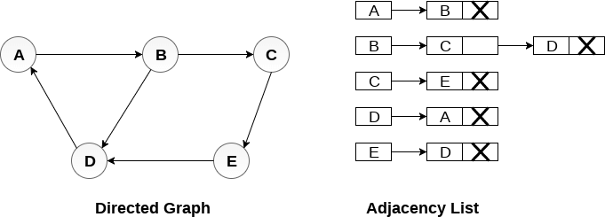

In a directed graph, the sum of lengths of all the adjacency lists is equal to the number of edges present in the graph.

In the case of weighted directed graph, each node contains an extra field that is called the weight of the node. The adjacency list representation of a directed

graph is shown in the following figure.

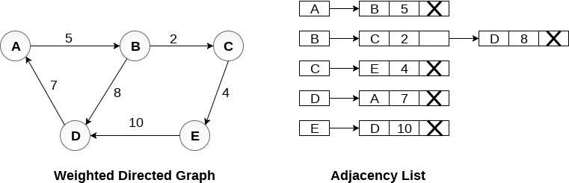

https://www.javatpoint.com/graph-representation